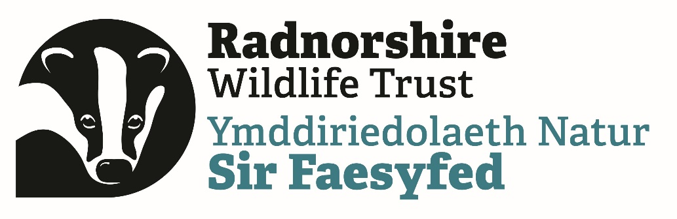
Feasibility study: collaborative habitat land management April 2022
Green Connections Powys is a collaborative Wildlife Trusts project across Powys that is working with community groups, small businesses, landowners and statutory organisations to take local action to address climate change and biodiversity loss and create a nature recovery network across the county. Together we are surveying and mapping wildlife, advising on habitat management and nature-based solutions, helping people encourage more wildlife into their communities and offering opportunities for upskilling and volunteering.
The project began in April 2021 and runs until March 2023. We are delivering across the whole county as a partnership between Montgomery Wildlife Trust, Radnorshire Wildlife Trust and the Brecknock Office of the Wildlife Trust of South and West Wales.
The aim of this feasibility study is to investigate opportunities for local collaborations between Small and Medium Enterprises (SMEs), contractors, farmers, lifestyle landowners and volunteers that deliver improved habitat management and provide mutual benefits.
We are looking for a contractor who has a good understanding of conservation activities, farming practices in Powys and an interest in facilitating collaboration between the farming sector and people interested in wildlife conservation.
Background
Small landowners frequently wish to manage their land for wildlife but often don’t have suitable machinery or livestock to do so. They may well rely on the goodwill of a local farmer to provide support when they have time, and this may not give the best outcome for wildlife. Habitat areas within larger farm holdings may be of a similar small scale and require different machinery or labour that isn’t easily provided within the farm business. Managing habitat areas collaboratively on a local scale could provide benefit through shared resources and efficiencies.
This feasibility study will investigate three aspects of this gap:
- How willing small landowners are to pay for habitat management to benefit wildlife in a similar way that people hire equipment and contractors for other small jobs
- Whether there are contractors or hire businesses around Powys/Mid Wales who already have specialist equipment for habitat management, or are willing to purchase small and specialist equipment as part of their enterprise
- The feasibility and appetite for setting up small machinery rings and other collaborative models of managing habitat based on the experiences of other groups of landowners and volunteers
There are a number of examples of collaborative conservation initiatives around Wales and the Borders, including meadows groups, community woodland groups, various CSAs and ‘cow clubs’, machinery rings as well as the Wildlife Trust’s own model for volunteer and contracted conservation activities. For this study we also want to find out if there is a small business model that could help meet the need for small-scale habitat management work in Mid Wales.

The maximum value of this contract is £5000 plus VAT. It will run from April 2022 to December 2022. Closing date for application for tenders is: 9am on the 20th of April.
Please send applications to: darylle@rwtwales.org
The contractor needs to:
- Consult with a range of small landowners around Powys to find out where the gaps in provision are for habitat management for wildlife and identify potential solutions
- Research the market for small businesses and contractors who undertake habitat management work in Powys. Establish what is available, where the gaps are and whether small businesses are open to a new enterprise or purchasing small-scale equipment.
- Provide a swot-type analysis of your findings including opportunities learnt from other collaborative groups
- Provide a short update on progress for Steering Group meetings in July, and September 2022.
- Provide a final report in December 2022 and present on your findings to a meeting, with recommendations for developing sustainable solutions to the need.
Green connections staff will be able help with contacting small landowners around Powys.
Please explain in your tender:
- Why you are a suitable contractor to deliver this project
- Your day rate and how you would allocate your time delivering the study
- A timeline with key delivery target dates through the duration of the contract.
- Any additional costs that make up the tender amount
- Whether VAT is applicable to your tender
- Describe your anticipated approach to this study
- Any other information to back up this tender
Staged payment for the service can be agreed quarterly in arrears subject to satisfactory progress, with final part payable after we have received the Final Report.
This project has received funding through the Welsh Government Rural Communities - Rural Development Programme 2014-2020, which is funded by the European Agricultural Fund for Rural Development and the Welsh Government.

