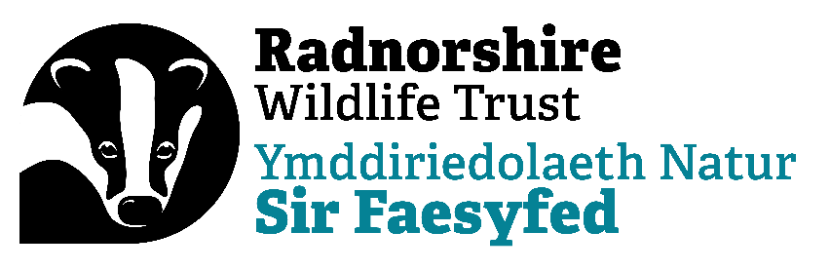

THE ORGANISATION

Radnorshire Wildlife Trust (RWT) is a charity that exists to protect and enhance Radnorshire’s wildlife and natural environment. It currently has 15 staff, 19 nature reserves, nearly 200 volunteers and a turnover of approximately £1 million. It has 2 offices including its headquarters at Warwick House.

We have expanded over the last few years and have a new 10 year strategy and business model. It is an exciting time to join our small, but ambitious and supportive team. The organisation is undertaking many firsts, transforming and updating systems, working with digital transformation principles and working hard to collaborate with partners to scale up the recovery for nature and to address climate change.

We have a proactive project development programme and are ambitious in both the nature and scale of the work we want to undertake over the next 10 years for both wildlife and communities, to include empowering young people to act for wildlife and climate. We are also working hard to diversify our income streams.

New staff will receive training, development and coaching, within the organisation, both for personal and professional development. You will have the opportunity to work within the wider Wildlife Trust movement to share best practice and seek support for your work, as we all move to increase our collective impact.

RWT strives to build and maintain a high profile in Powys and beyond. It currently raises and manages around £1 million pounds a year, engaging with a range of external organisations. It has a membership of over 1,200; we’re growing fast. We have nearly 7,000 social media supporters. RWT works extensively with volunteers, some of whom are organised through third-party groups within the county using the principles of community empowerment.

RWT is one of 46 Trusts which together make up The Wildlife Trusts, a national movement of independent local Trusts active in all aspects of wildlife conservation.
RWT is currently the smallest UK mainland Trust, but we have a long history of delivering projects with impacts far larger than our size.

RWT has its headquarters at Warwick House in Llandrindod Wells. It owns Gilfach Nature Reserve, just outside Rhayader, where it bases its nature reserves operations and stages events.

RWT has excellent governance and has recently updated its HR processes.
RWT strives to be an equal opportunities employer.

___________________________________________________________________

