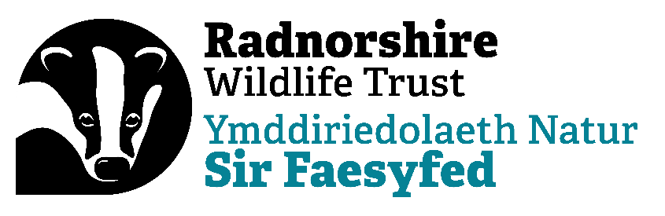

Campaigns and Advocacy Officer – Wye Now Programme
Job Description
IDENTIFICATION OF JOB

Working base: Warwick House, Llandrindod Wells (with travel within England and Wales)

Contract: Fixed-term – until March 2026 - Hybrid working

Responsible to: CEO

Responsible for: Any Campaign volunteers and contractors

Working Hours: 22.5 hours per week, with flexible working arrangements. Some evening and weekend work required for which Time Off In Lieu will be awarded.

Overall purpose

To deliver on the trusts Campaign and Advocacy ambitions around the River Wye, rivers and water management within the upper catchments, championing a clear vision and messaging around the social, health, economic and wellbeing benefits of clean and healthy rivers with well managed water supplies.

Main responsibilities

Build and deliver campaign actions, creating on and off-line engagement tools and key messaging to build, harness and direct support for change, in association with the wider RWT team and our partners and stakeholders.
- Develop campaigns and supporting plans to ensure visibility and buy-in to delivery across a campaign partnership, of community groups and stakeholders, that you’ll develop, engage and grow.
- Manage allocated central and partnership-led resources to ensure campaigns are delivered effectively and to strategic steer(s)
- Drive campaigns and advocacy forward with energy and commitment, demonstrating clear and engaging communications to drive strong engagement approach that influences and delivers change
- Support delivery of the advocacy strategy in association with the CEO, which includes attending regular meetings such as the Wye Catchment Partnership (CaBA).
- Work closely with colleagues in Wildlife Trust Wales and The Wildlife Trusts to ensure your work has national impact and messages are aligned from local to UK level.

Developing and increasing interest and opportunity in ‘Green Investment’ deals with investors and landowners.
- Increase awareness and education around the potential for Green Investment locally and regionally and it’s role in delivering public benefits including healthy, clean rivers.

Communications and publications
- Steer the development and production of suitable campaign materials, publications and content that will suit and inspire identified audiences through a variety of channels (social, digital, publications and the media - broadcast, print and online)
- Coordinate and deliver campaign press and media activity, working with media leads in projects and partner organisations.
- Assess how campaign action boosts the necessary public policy change and new legislation.
- Coordinate joint delivery with partners and other relevant organisations as applicable.

All staff are ambassadors for the organisation both internally and externally and expected to always act in a professional manner. They are required to abide by organisational rules, policies and procedures as laid down in the staff handbook, adopt environmentally friendly working practices, set and maintain high personal standards of efficiency and customer care and foster a ‘can do’ culture based on ownership, initiative, teamwork and exchange of information.

PERSON SPECIFICATION

PROFESSIONAL SKILLS AND QUALIFICATIONS

Essential skills
- Ability to communicate well across different audiences in writing and in person
- Excellent organisational skills
- Experience of campaigning or organising to achieve change.
- Experience of managing and working with volunteers.
- Good project management skills, able to balance a range of priorities.
- Familiarity with campaigning across platforms
- Experience meeting and influencing decision makers

Desirable skills
- Experience getting local media coverage
- A good understanding of data protection as applicable to the UK
- Experience organising events

Personal Qualities
- Passionate about driving positive change for nature and climate
- Passionate about UK rivers, clean water and healthy vibrant catchments.
- Energetic, friendly, and good humoured.
- Confident in communicating and, able to seek and balance a range of views and stakeholders, influencing where required.
- Passionate about the role of campaign to achieve change and win support from local to national level.
- Flexible
- Self-starter
- Passionate and prepared to learn, unlearn, and relearn
- Honest and inclusive
- Willing to take ownership of problems and identify solutions

