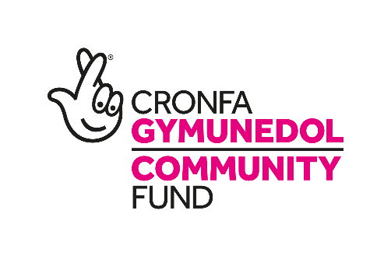
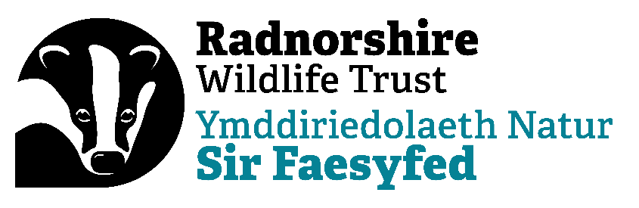

Community Wildlife Officer
Job Description
Post title: Community Wildlife Officer
Responsible to: Head of Conservation
Responsible for: Volunteers and Contractors
Duration: 2-year fixed term contract.
Working Hours: 0.8FTE (30 hours per week) with flexible working arrangements.
Salary: £24,570 (pro rata)
Pension: Enrolment into the NEST auto-enrolment scheme, currently with 3% minimum employee’s contribution matched with a 6% RWT contribution.
Holiday Entitlement: 25 days per annum plus Bank Holidays (pro rata)
Working base: Warwick House, Llandrindod Wells (with travel within England and Wales)

Closing date: 2nd March 2025
Provisional interview dates: 12th March 2025

The role is funded with thanks to the National Lottery People and Places grant.

Overall purpose

The Community Wildlife Officer will play a crucial role in fostering community-led conservation initiatives across Radnorshire.

This position is aimed at empowering local residents and groups to actively participate in biodiversity enhancement and habitat management, with the goal of creating resilient, nature-positive communities.

The Community Wildlife Officer will provide on-the-ground support, expert guidance, and tailored training to community groups, helping them to design and implement sustainable conservation practices in shared and personal green spaces.

Additionally, the Community Wildlife Officer will build strong, collaborative networks, enabling local champions to advocate for and maintain biodiversity efforts that support Radnorshire Wildlife Trust's broader mission to increase ecological stewardship across the county.

All staff are ambassadors for the organisation both internally and externally and expected to always act in a professional manner. They are required to abide by organisational rules, policies and procedures as laid down in the staff handbook, adopt environmentally friendly working practices, set and maintain high personal standards of efficiency and customer care and foster a ‘can do’ culture based on ownership, initiative, teamwork and exchange of information.

Main responsibilities
Community Engagement and Support:
- Work directly with local communities, groups, and individuals to increase engagement in nature conservation efforts.
- Organise and deliver talks, workshops, and on-site training focused on biodiversity, habitat management, and conservation practices.
- Build relationships with community leaders and groups to foster partnerships that support conservation goals.
Habitat Management and Technical Guidance:
- Conduct site visits and provide expert advice on creating and managing wildlife habitats within community and personal green spaces.
- Develop and share tailored habitat management plans to enhance local biodiversity.
- Collaborate with local groups to establish ongoing biodiversity-enhancing practices.
Project Monitoring and Reporting:
- Track project progress by gathering qualitative and quantitative data on community engagement and ecological impact.
- Create detailed reports on biodiversity surveys, habitat improvements, and community feedback.
- Regularly report project outcomes to Radnorshire Wildlife Trust management and funders, ensuring transparency and adherence to project goals.
Volunteer Coordination and Training:
- Recruit, train, and support volunteers to assist with habitat monitoring, data collection, and community outreach.
- Work closely with “Wildlife Champions” and other community advocates, providing them with the tools and resources to sustain local conservation efforts.
Resource Development and Online Engagement:
- Develop educational materials, including online workshops and resources, to reach a broader audience.

PERSON SPECIFICATION

Essential Skills
- Ability to communicate well across different audiences
- Excellent organisational skills
- Experience of surveying or ecology work
- Experience of managing and working with volunteers.
- Experience of community outreach in the local area.
- Good project management skills, able to balance a range of priorities.

Personal Qualities
- Energetic, friendly, and good humoured.
- Confident in communicating and, able to seek and balance a range of views and stakeholders, influencing where required.
- Passionate about the local community
- Flexible
- Self-starter
- Honest and inclusive
- Willing to take ownership of problems and identify solutions

